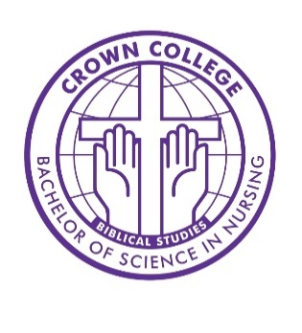
Crown College Nursing Program
Direct Admission Application
Return completed application to nursing@crown.edu.
To be completed after you have submitted your general admission application to Crown College.
In this application, you are declaring your intent to be considered for acceptance to the Crown College Nursing Program. Space may be limited; not all qualified applicants are guaranteed acceptance. All acceptance notifications will be sent via email within one month of submission.
Name ____________________________________ Date ___________________________________
Expected year to start junior nursing classes (ex: “Fall 2026”) _________________________________
Home Address _______________________________________________________________________
____________________________________________________________________________________
Date of Birth __________________ Email _______________________ Cell _____________________
- Please attach one letter of recommendation from someone other than a friend or family member.

- Essay question (200 word minimum): Why do you want to pursue a Bachelor of Science in Nursing degree at Crown College?

NOTE: By submitting this application, the applicant releases Crown College, its employees, consultants/contractors, and all individuals involved in providing or collecting data, from any responsibility related to perceived/actual harm or damages as a result of this application and verification process. The applicant agrees to waive all rights to artifacts submitted, data collected, and scores assigned for the purposes of establishing priority in the acceptance process. The applicant understands that they may only receive their standing on the waiting list and not any other data such as scores, reviewers' comments, or acceptance priority.

